1. **Write a command to get the Python version you are using.**

Ans : Type python in cmd to get version of python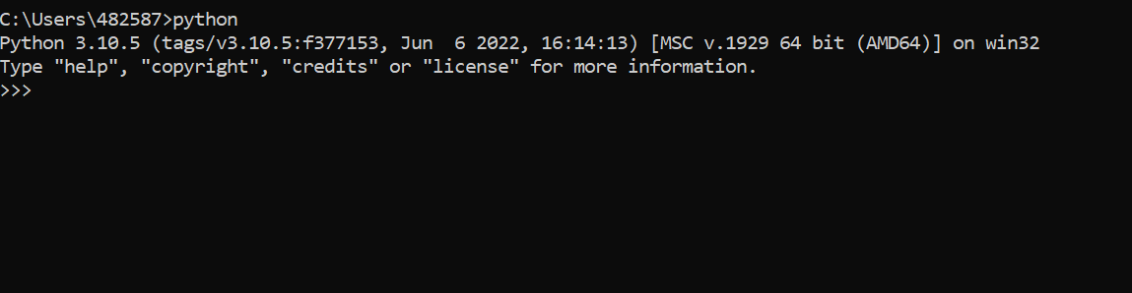

1. **Write a python script to print Hello Python on the screen directly in the command line.**

Ans : Open cmd and type python

print(« Hello Python »)

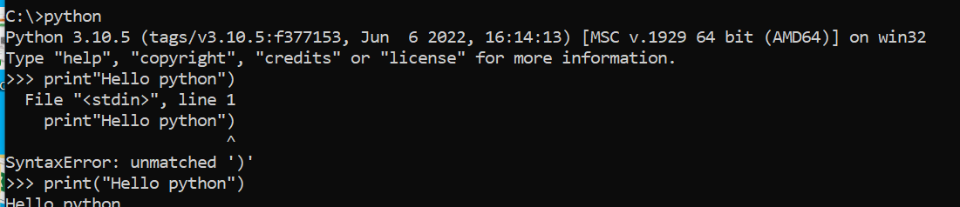

1. **Write a python script and store it in a file and execute the file from the command line.**

Ans : open Vs code

Create a python file , hello.py and save in vs code in c drive .

Open cmd , copy folder path and run the python with python file name.

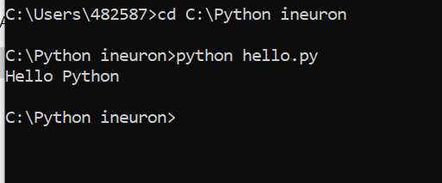

1. **Write a python script to print Hello Python on the screen using visual studio code.**

Ans : Open vs code and typr print(« Hello python »)

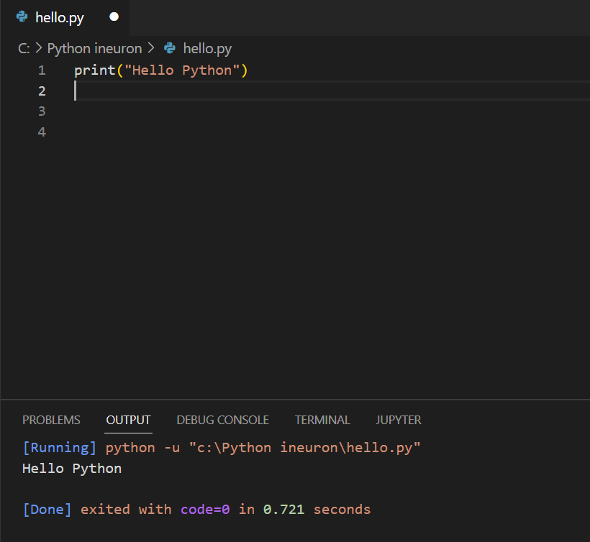

1. **Write a python script to print Hello on the first line and Python on the second line**

Ans :

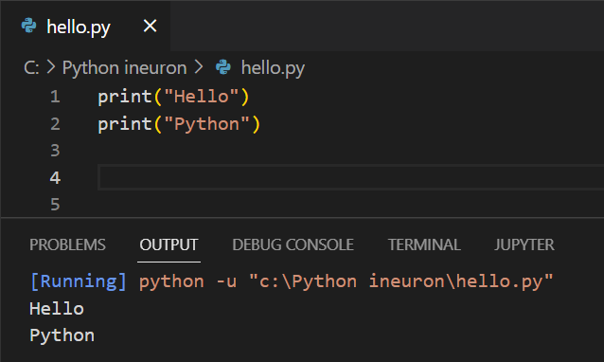

1. **Write a python script to print “MySirG” on the screen**

Ans :

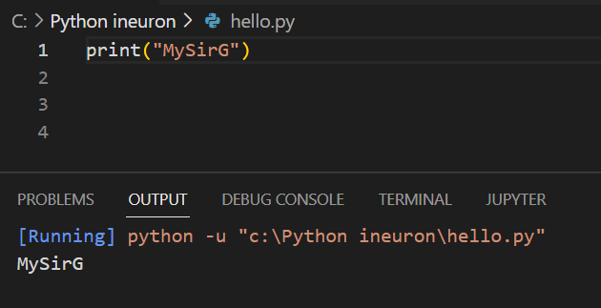

1. **Write a python script to print “Teacher’s Day” on the screen**

Ans :

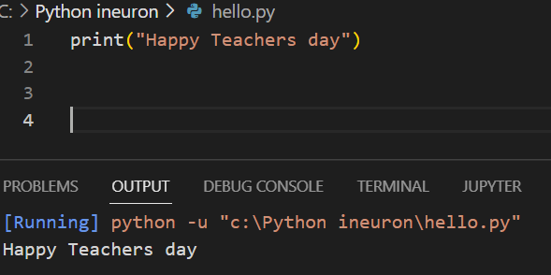

1. **Write a python script to print the value of a variable. Variable contains your name as data.**

**Ans :**

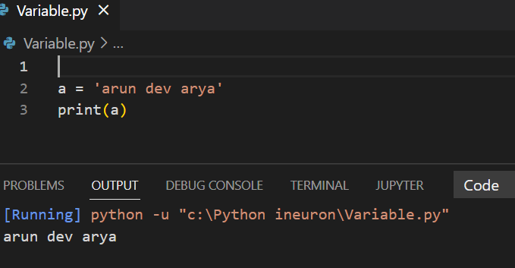

1. **Write a python script to create variables to store your name, age, qualification, years of experience and print it.**

**Ans :**

name = 'arun dev arya'

age = 29

Edu = 'Bachelor'

Exp = '8 years'

print(name)

print(age)

print(Edu)

print(Exp)

1. **Write a python script to print values of three variables, each in a new line. Variable contains integer values**

**Ans :** a = 10

b = 29

c = 30

print(a,b,c, sep='\n')